<https://facebook.github.io/react-native/docs/getting-started.html>

<https://github.com/nodejs/node-gyp/issues/1045>

1. Install JDK
2. Install python 2.7
3. Install android studio
4. Install nodejs
5. Install react-native-cli globally



1. Creat app



1. Open app folder with android studio and install missing platform
2. Add environment variable & edit path variable

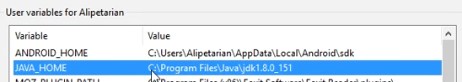

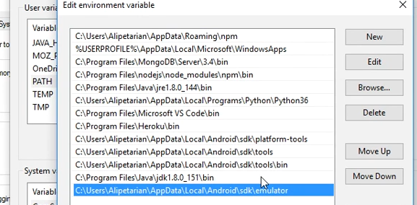

1. List and run emulator from cmd

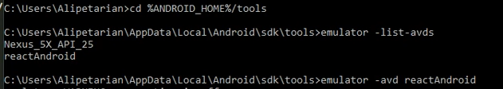

cd /d %ANDROID_HOME%/tools

C:\Users\AamirShahzad\AppData\Local\Android\Sdk\tools>emulator -avd Nexus_5X_API_26

1. Open run and run command

react-native start --reset-cache

or

react-native start

1. Run app



1. To run on device run > open android folder in android studio > run app in device > repeat previous steps

**OTHER METHODS**

npm i -g create-react-native-app

npm i -g react-native-cli or npm install -g expo-cli